This is the initial screen when the program runs. For the time being, to use manager access enter “AUser” in the field or “BUser” for employee access. Manager’s have access to all functions, employee’s do not have full access to the program.

Also for the time being, enter “pass” to get through login.

Here we have the main menu for the program. Enter only numbers 1 through 8 according to desired destination.

Ticket Menu Walkthrough

When option 1 is selected, the user is able to enter the subject for the ticket. Next is the priority level for the ticket, for viewing purposes. Afterwards the user is asked to enter the recipients name, in this case Frank the assistant manager. The following input is the message, and last the user is able to create a ticket number for the ticket. Ticket numbers are needed for reading or updating tickets, don’t forget these.

After the ticket is created successfully, you’re able to read the ticket if you remembered the ticket number. From the start of the program, you’re able to read ticket numbers : 2, 3, and 4 from which after you create tickets you can access those as well. If you enter a ticket number that doesn’t exist, you’ll be returned to the Ticket Menu. In the picture, you can see everything entered from our created ticket #7. The program takes you automatically back to the Ticket Menu.

Entering 4 in the Ticket Menu will take you back to the Main Menu.

Inventory Menu Walkthrough

Entering 2 in the Main Menu will bring you to the inventory menu. This menu has functions only managers can use, and the system checks for the credentials. Enter 1 to find an item. From the start of the program, you may enter 1, 2, 3, and 4 and after a manager creates an item you’ll be able to view that if you remember the item number.

Option 2 in the Inventory Menu will give a report of all items in the database. Option 3 will take you back to the Main Menu, but let’s take a look at Option 4.

When you select Option 6 to delete an item from inventory, you are able to enter the item number. In the picture you can see we deleted item number 1, and the report shown is updated with the new location for the new item in inventory.

Staff Menu Walkthrough

In the Staff Menu, you’re able to show Staff Info then you enter “George” or “Frank” at start up. Show schedule show’s the current week’s schedule for the store. The staff report is a catalog of all current employees and the information associated with them.

Manager Menu Walkthrough

The main section of the Manager Menu lets you create, update, and delete staff. After using any function, you will be returned to the Main Menu.

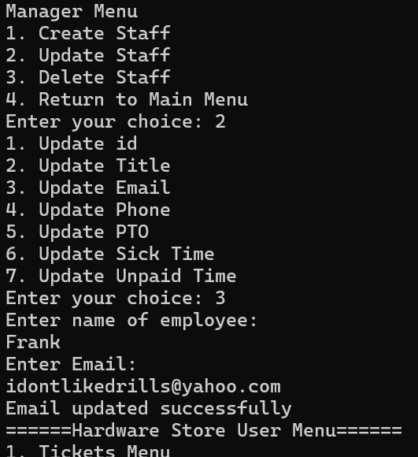

When you delete an employee, you’ll have to enter their name. If you need to see the changes, you can view them in the Staff Menu.

Exit Program Walkthrough

Customer Menu:

The customer menu can be accessed by entering option 3 in the main user menu.

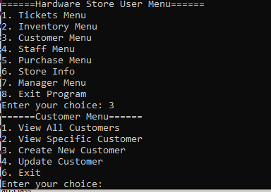

To view all customers currently in the database, enter option 1: 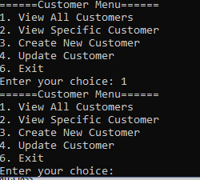

At this time the list will not display anything since there are no customers in the database.

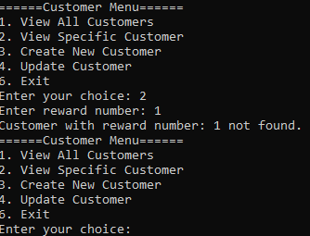

Entering option 2 allows you to search specific customers by reward number. Again, since there are no users in the database, a message stating the user was not found appears.

Entering option 3 allows you to create new customers to be added to the database. You will be prompted to enter the customer's full name, phone number, reward number, and starting reward point value which will typically be 0.

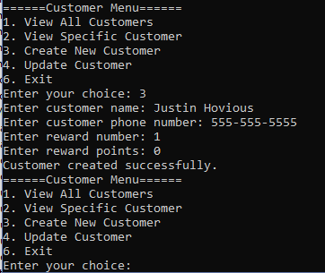

Now that a customer has been added, use option 1 again to display all current customers.

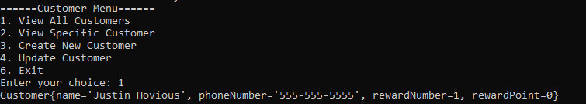

Similarly, using option 2 will let us search for this customer by their reward number:

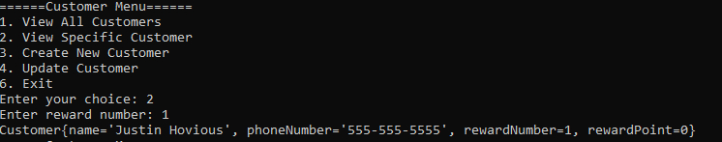

Option 4 can be used to update customers that are already in the database.

This example shows us changing the customer’s phone number and reward points:

